Section 3

1. SELECT *

FROM customers;

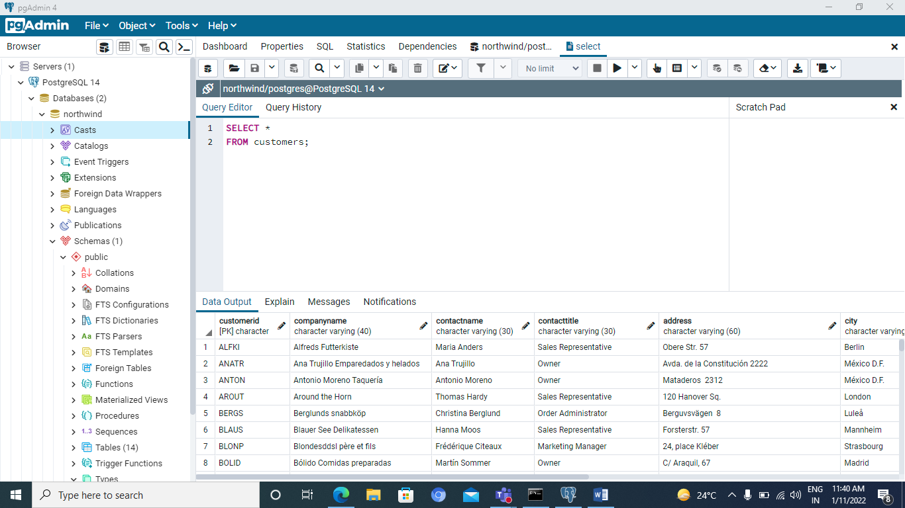

2. SELECT * FROM employees;

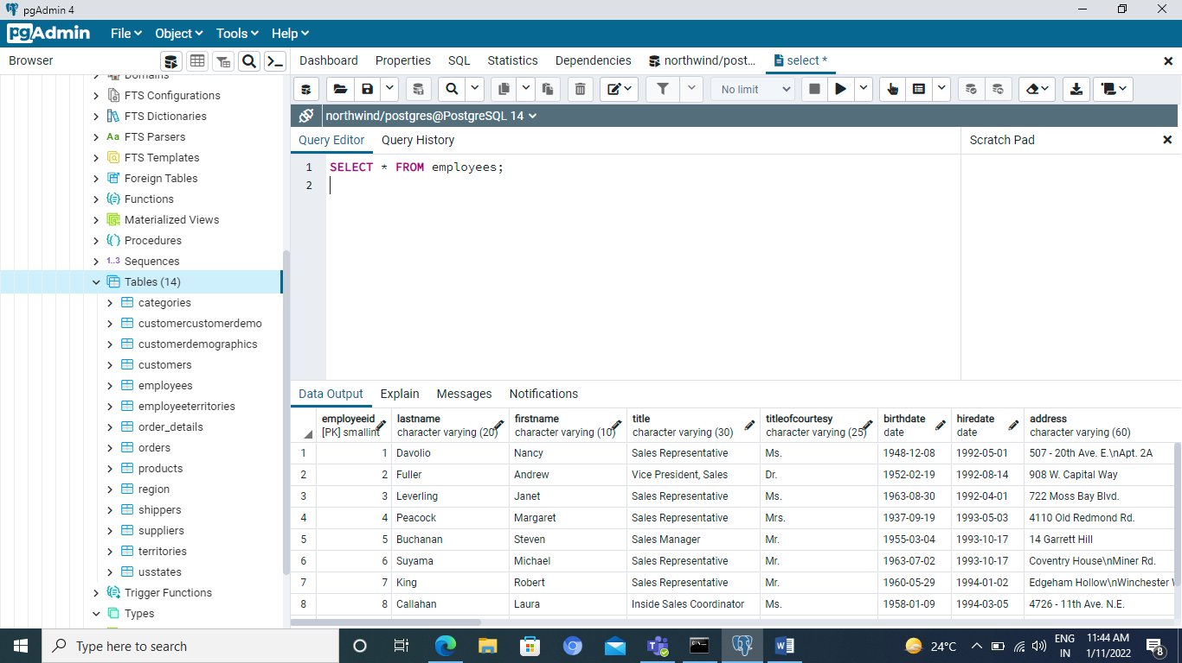

3. SELECT companyname,city,country

FROM suppliers;

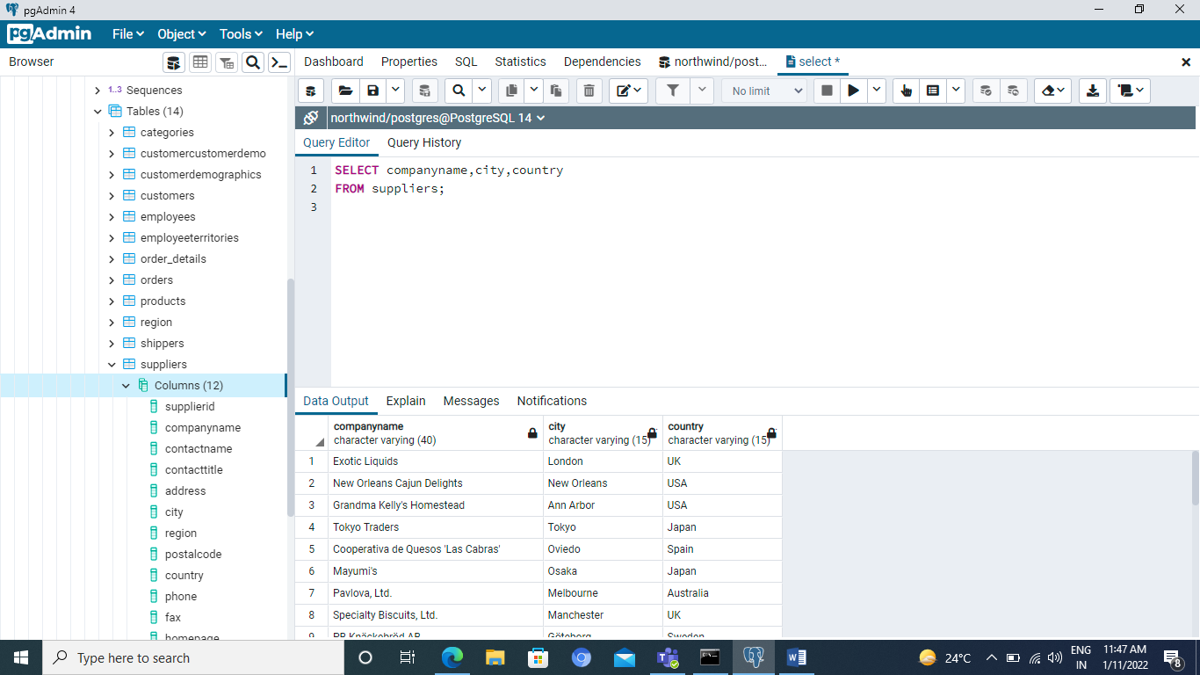

4. SELECT categoryname,description

FROM categories;

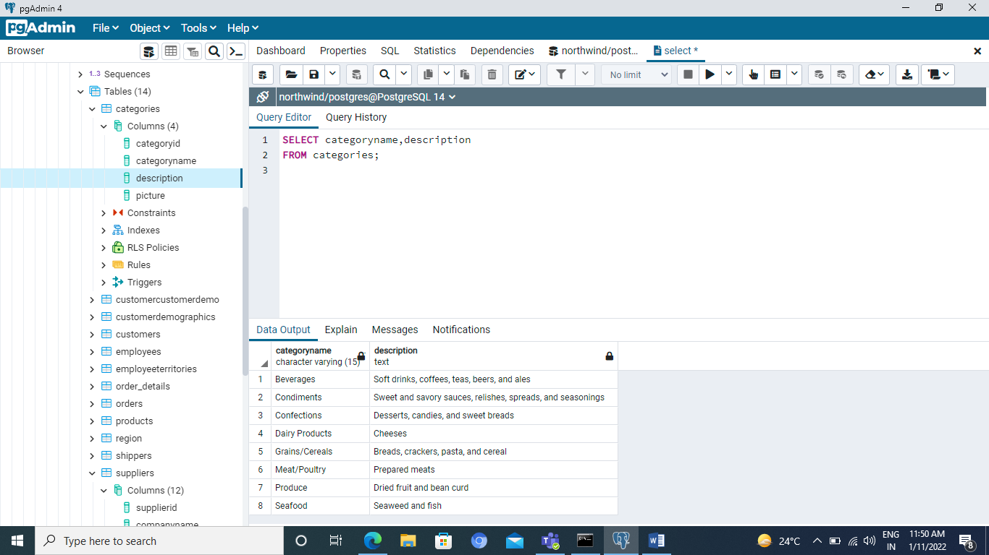

5. SELECT DISTINCT country

from customers;

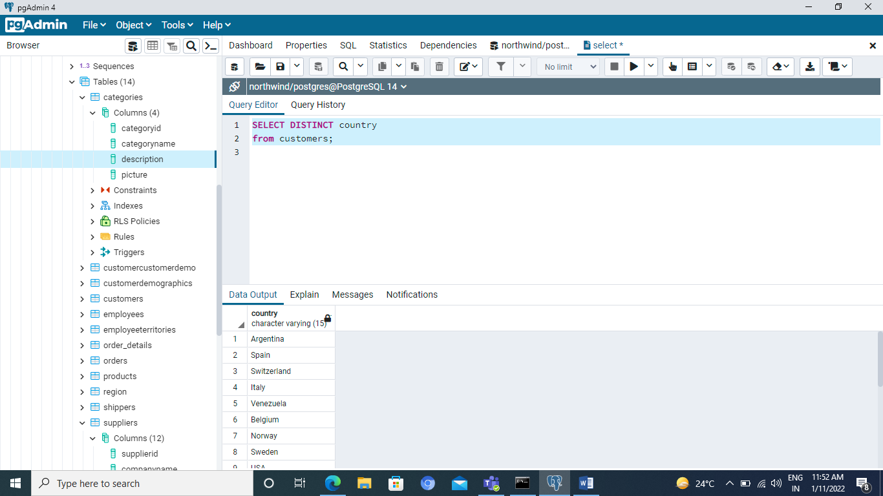

SELECT DISTINCT city,country

from customers;

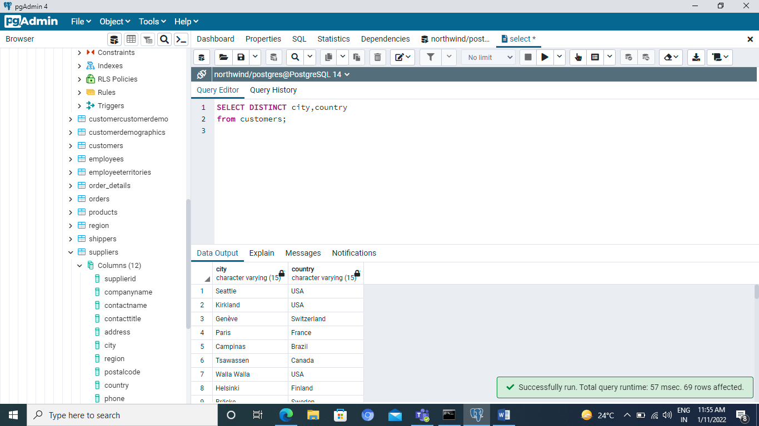

SELECT DISTINCT region

from suppliers;

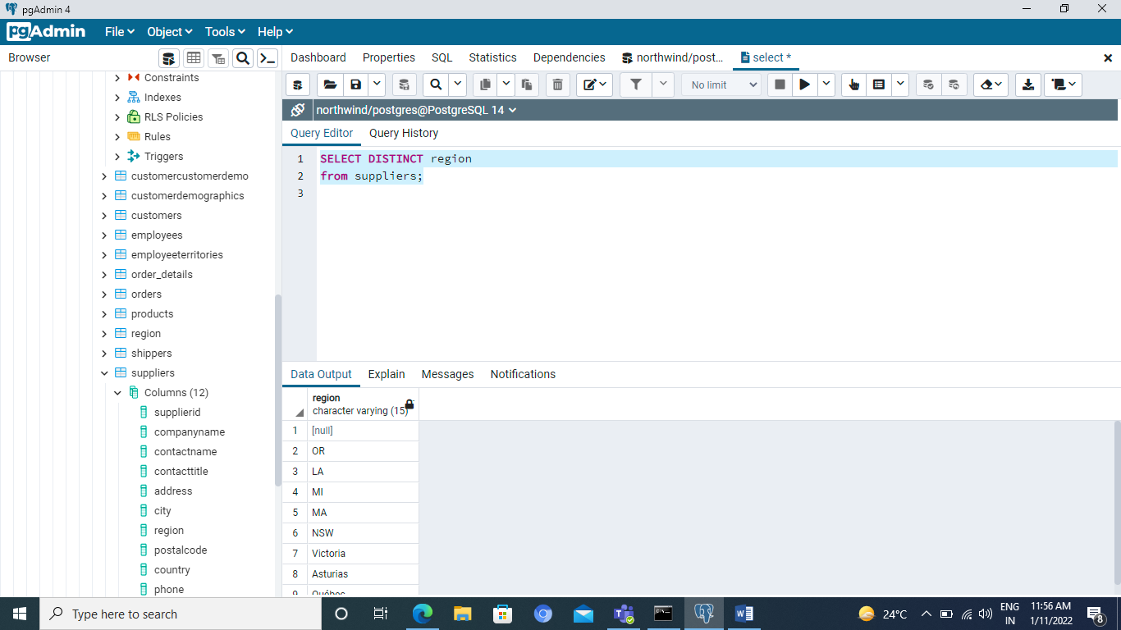

select count(*)

from products;

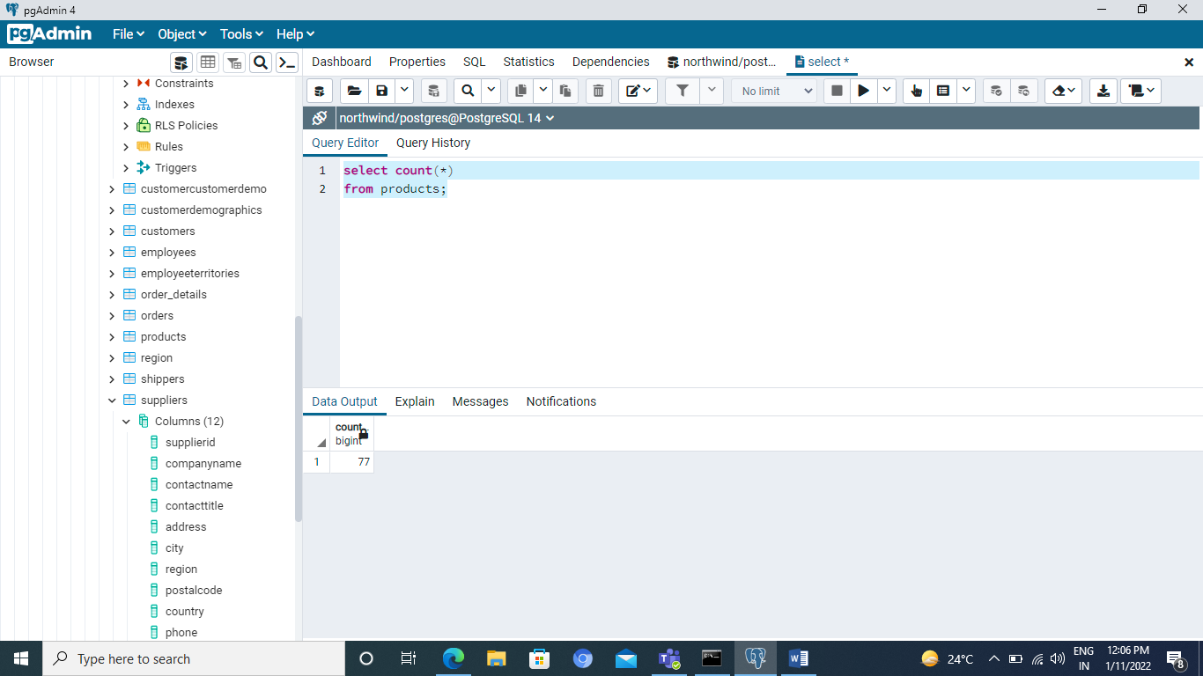

select count(*)

from orders;

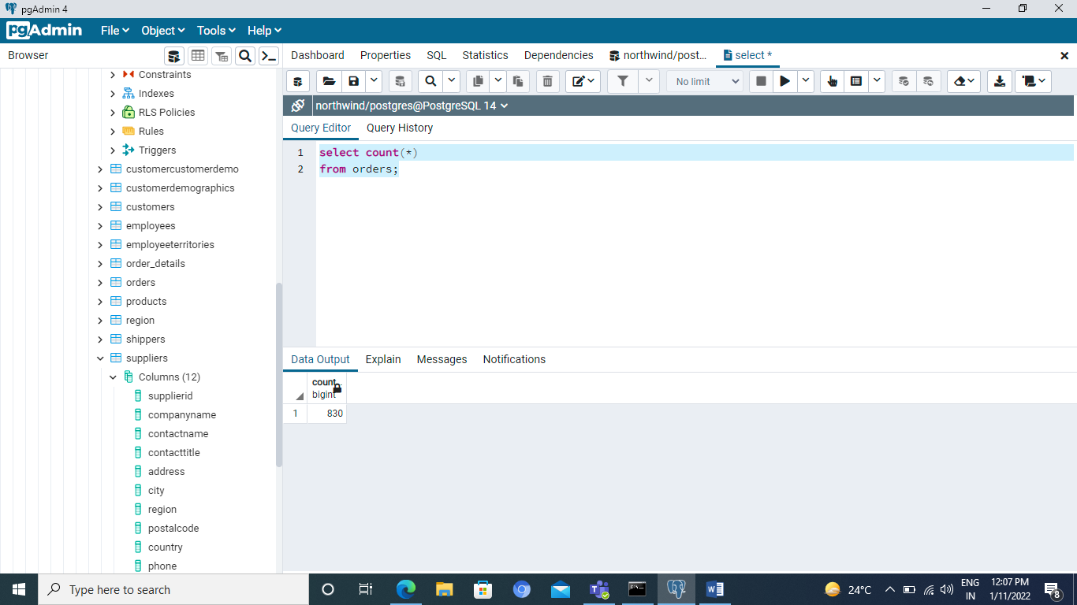

select count(distinct city)

from suppliers;

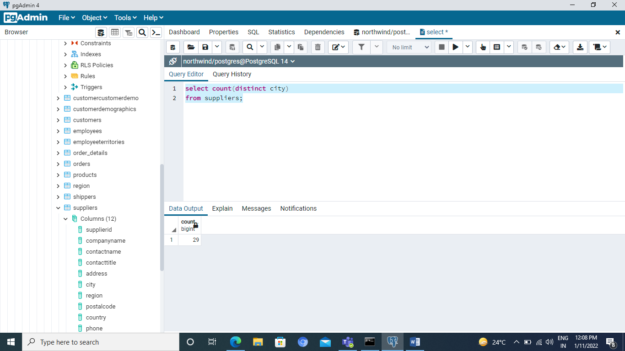

select count(distinct productid)

from order_details;

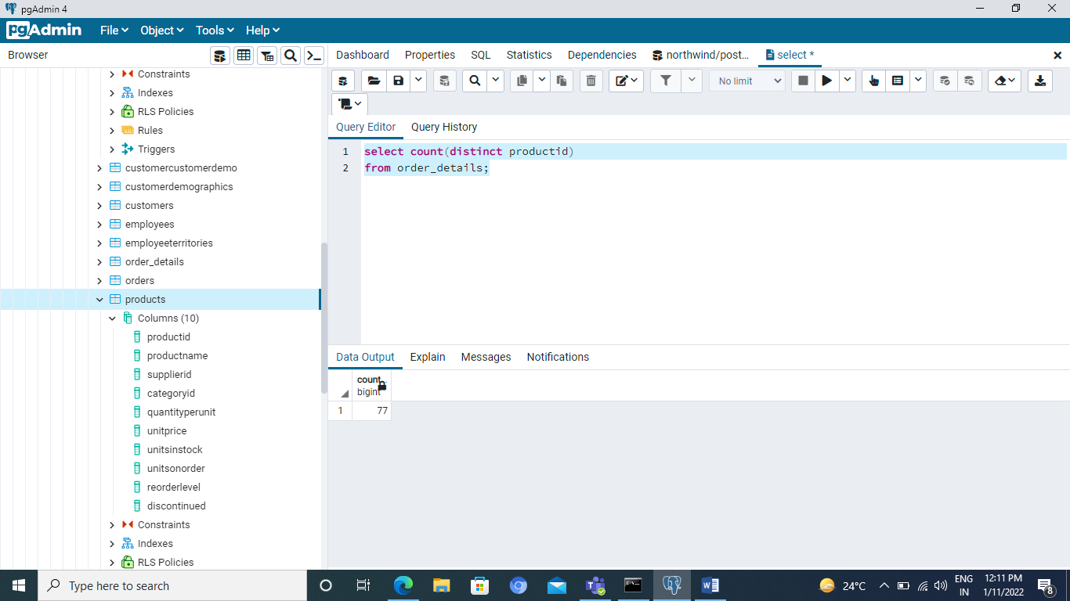

SELECT customerid,shippeddate-orderdate

FROM orders;

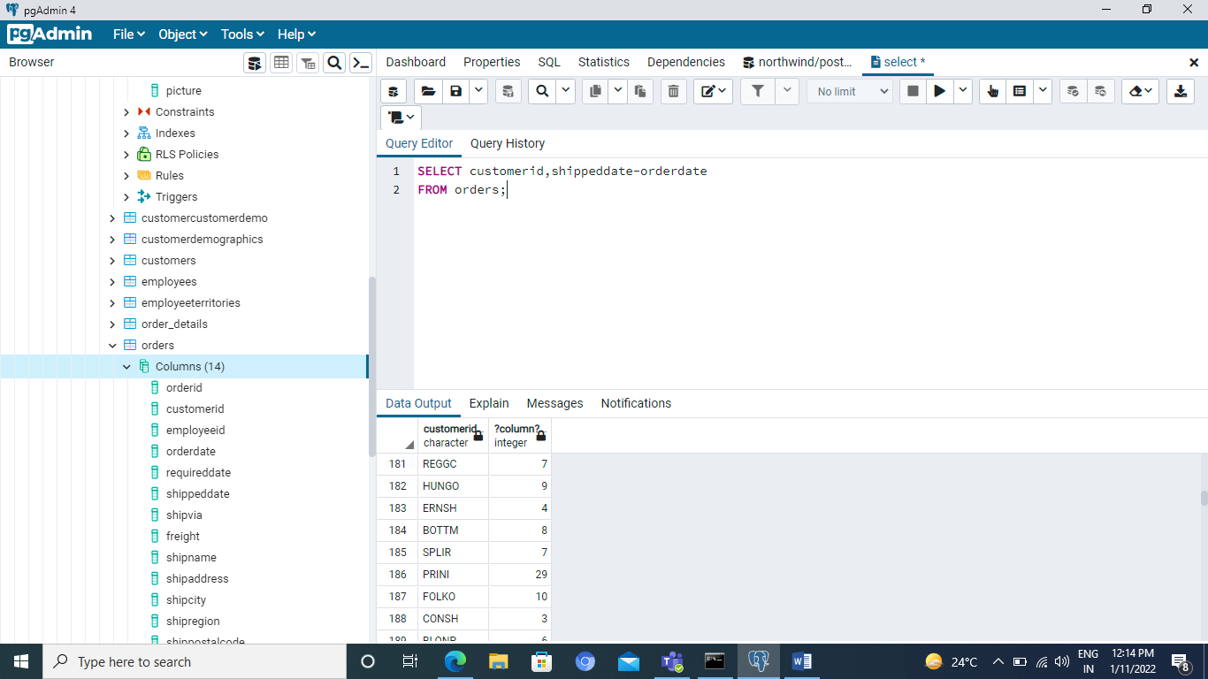

SELECT orderid, unitprice*quantity

FROM order_details;

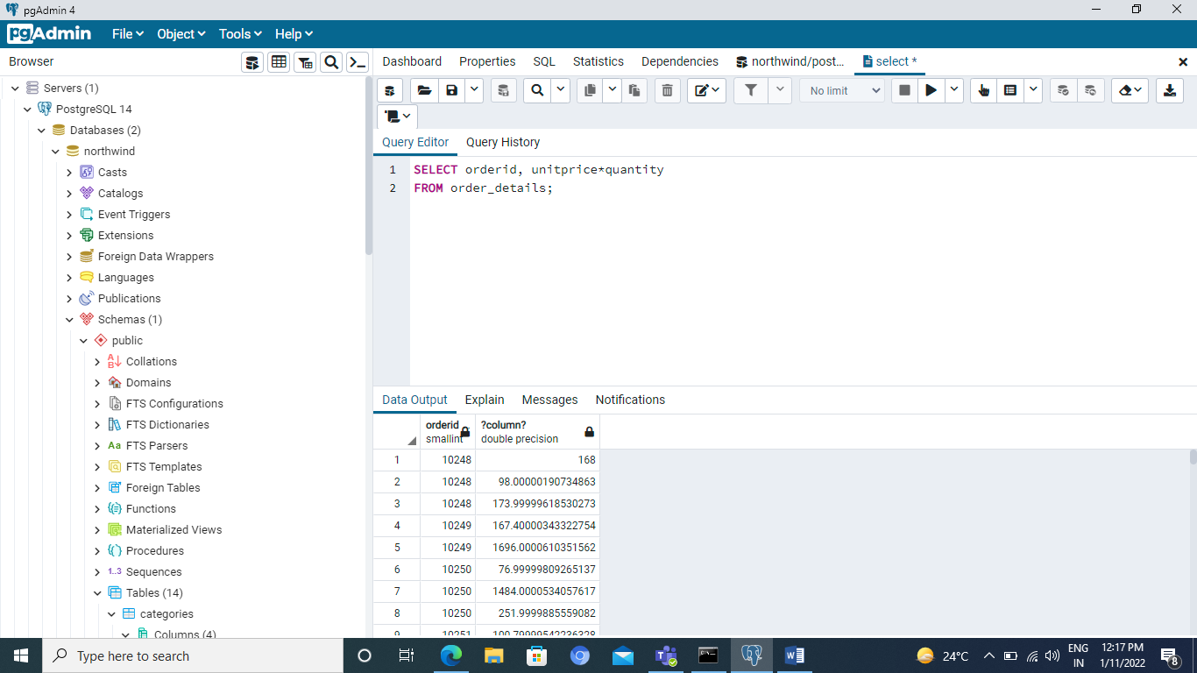

**Assignment**

1. Select all fields, and all records from actor table

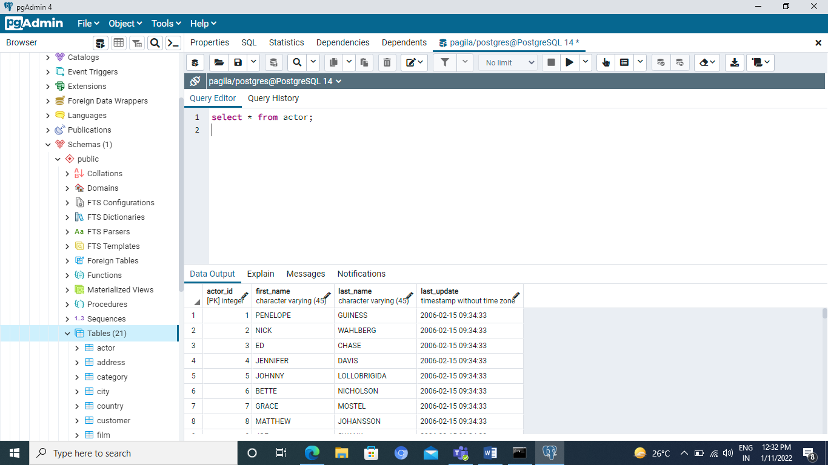

2.Select all fields and records from film table

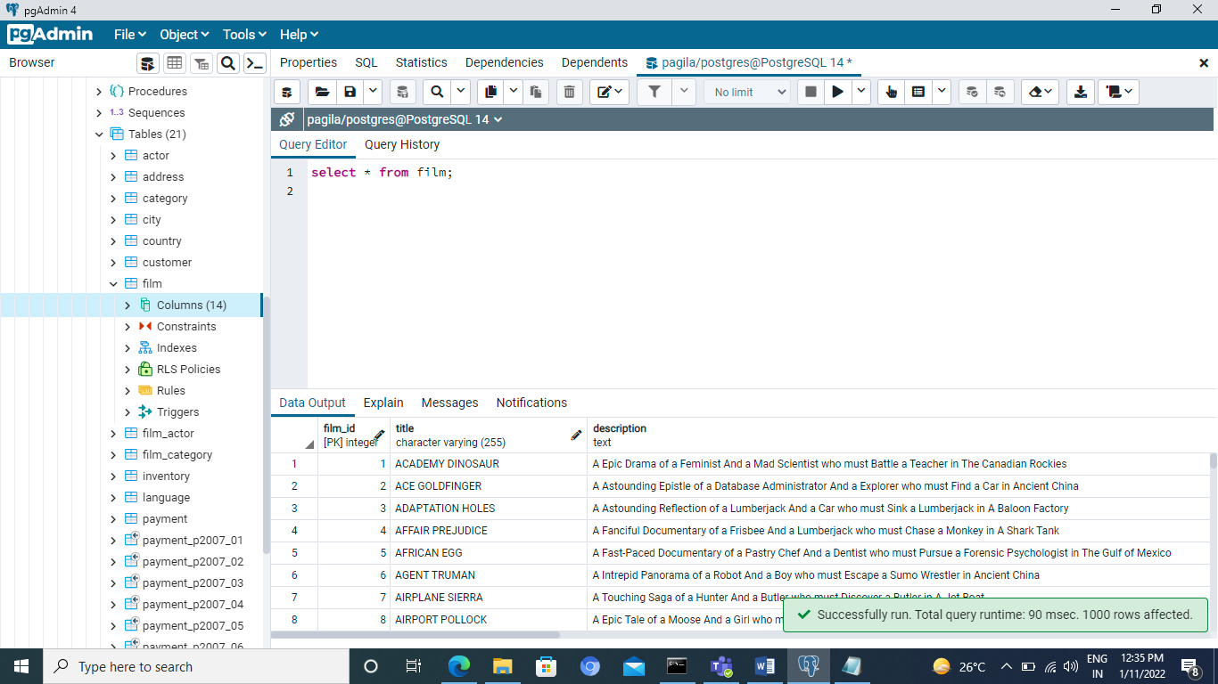

3.Select all fields and records from the staff table

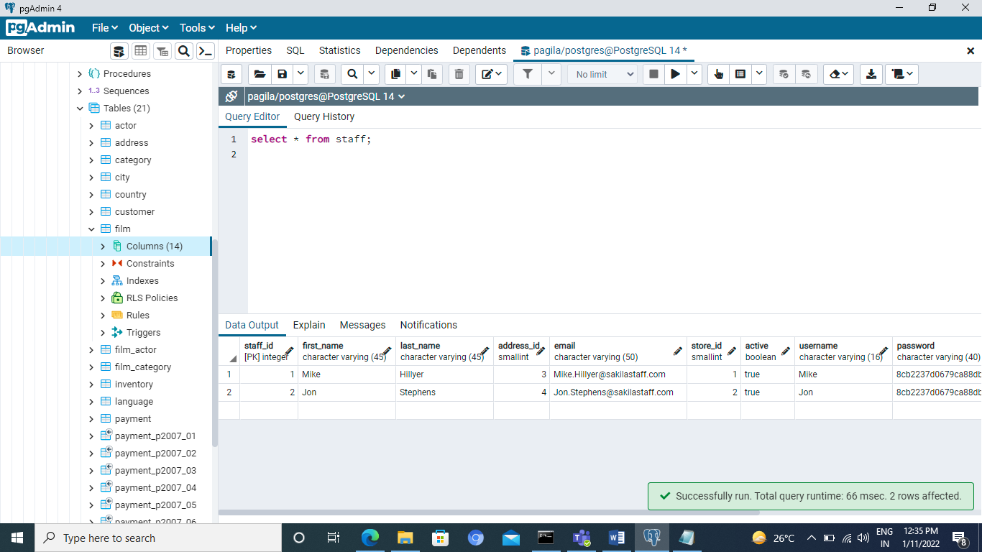

4. Select address and district columns from address table

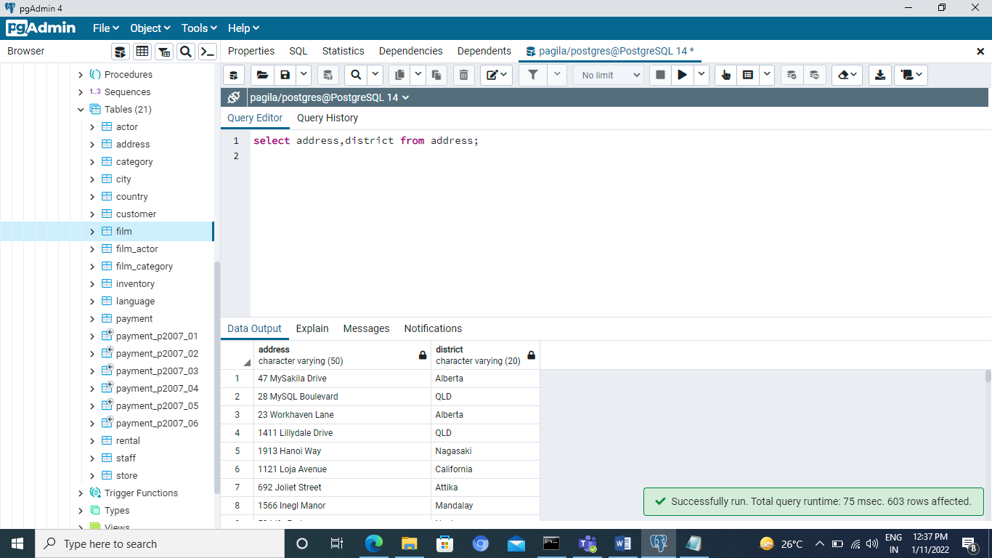

1. Select title and description from film table

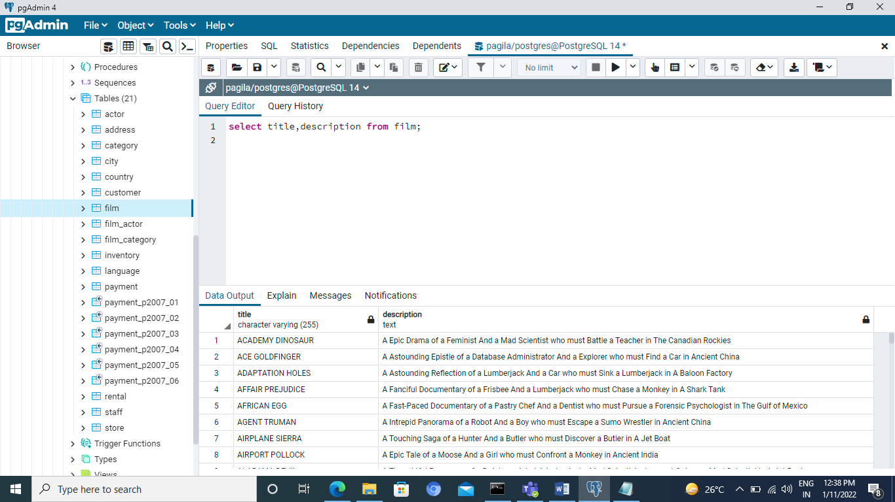

1. Select city and country_id from city table

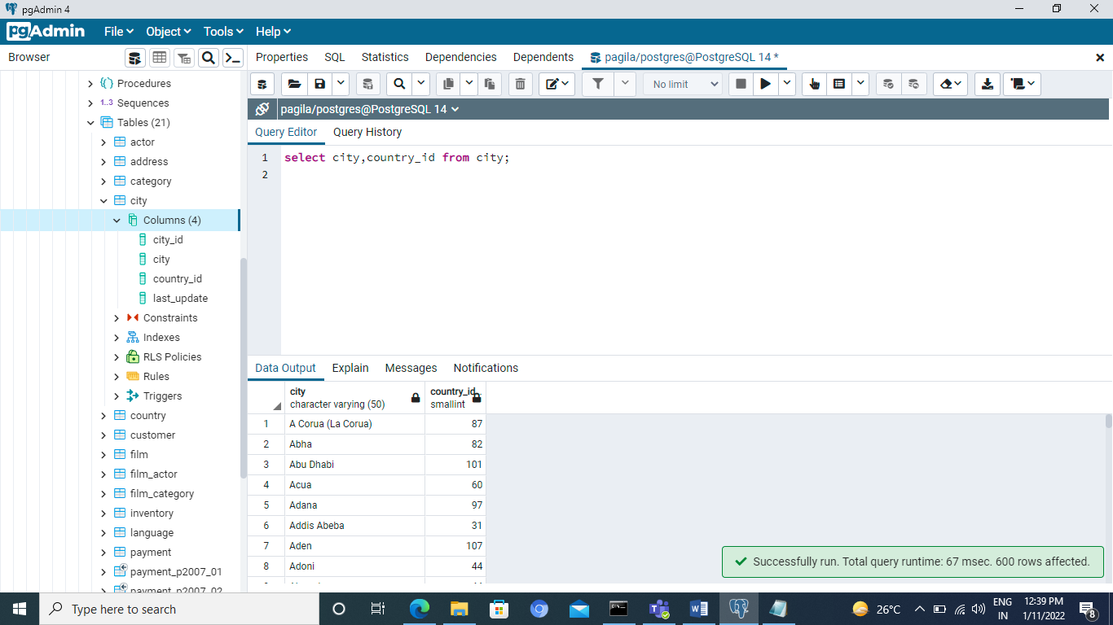

7. Select all the distinct last names from customer table

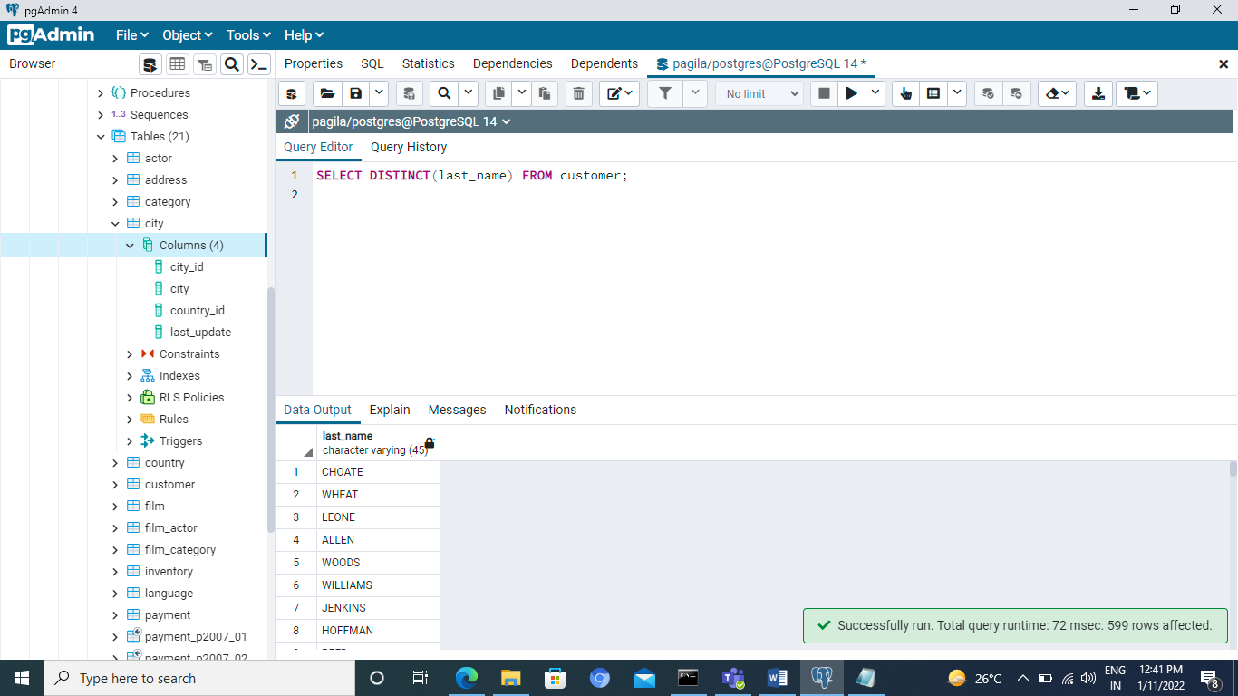

8.Select all the distinct first names from the actor table

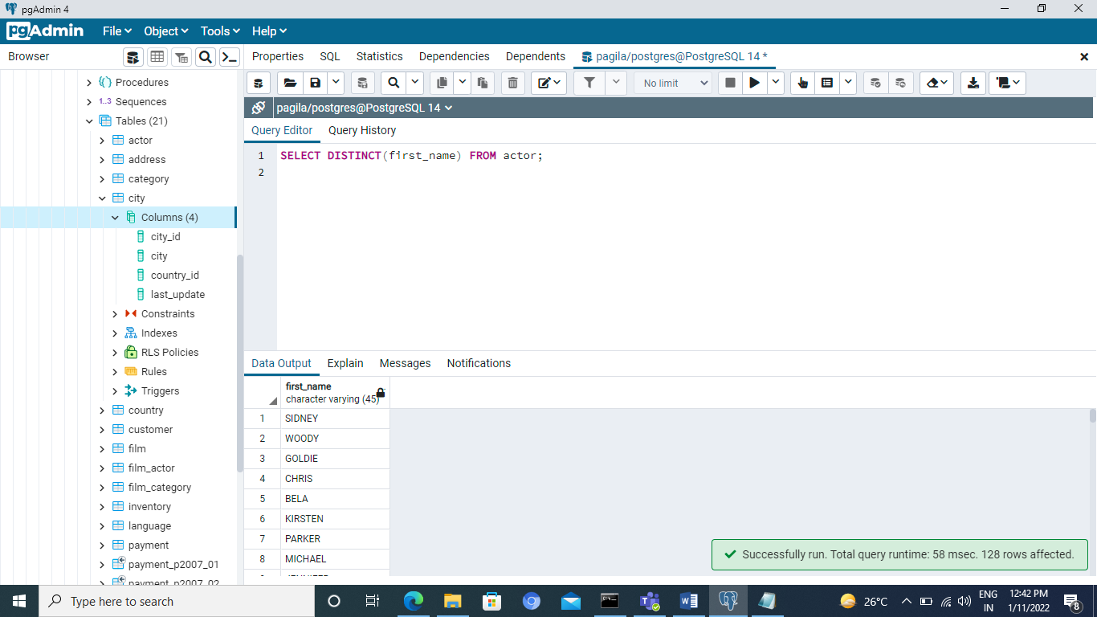

9. Select all the distinct inventory_id values from rental table

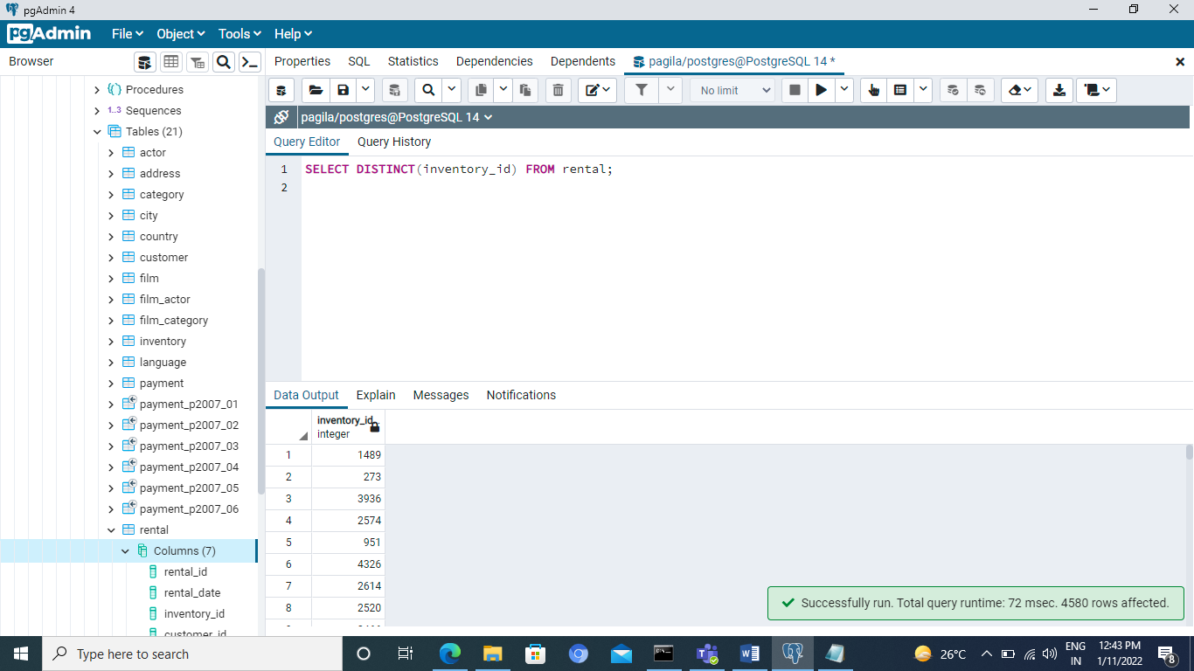

10. Find the number of films ( COUNT ).

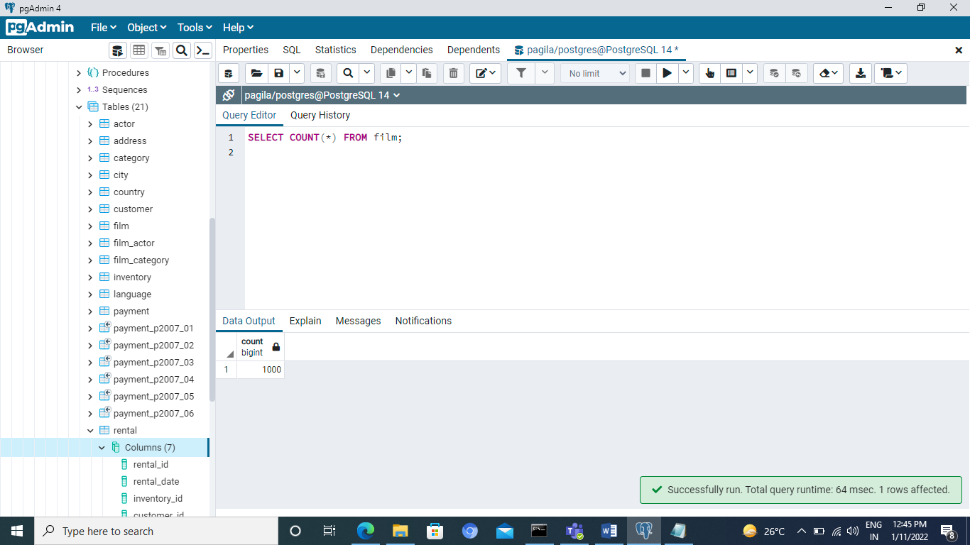

11.Find the number of categories.

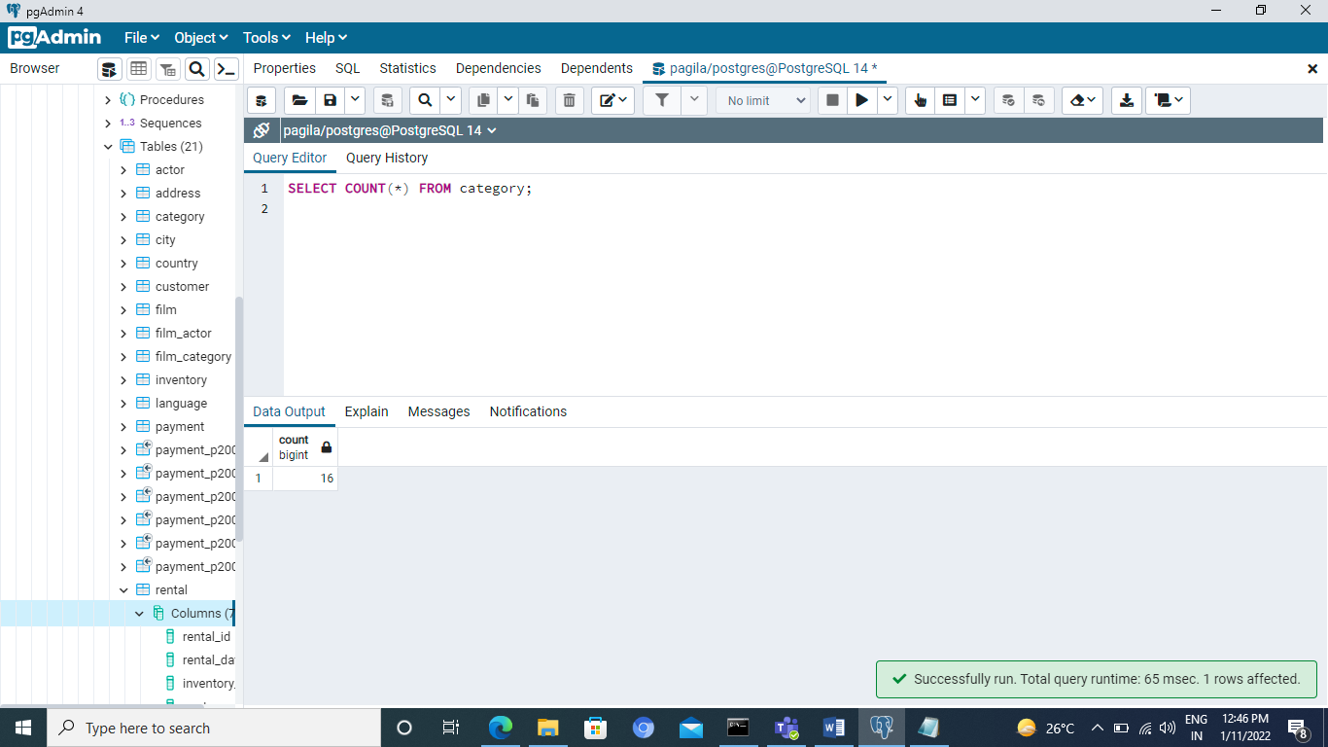

12. Find the number of distinct first names in actor table

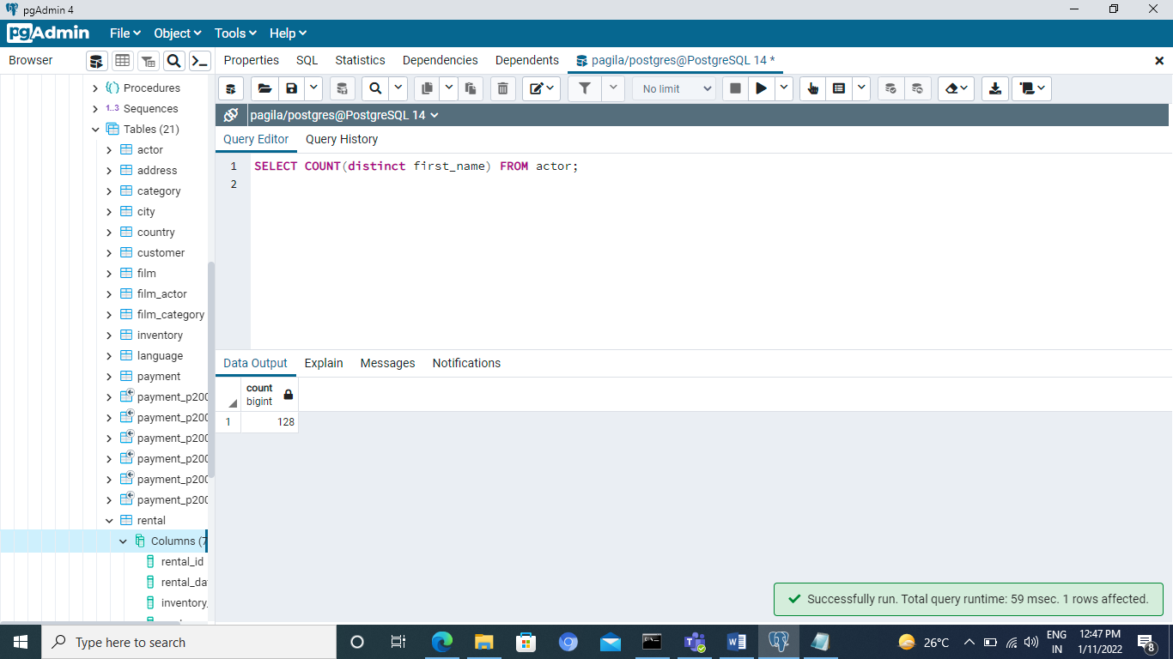

13. Select rental_id and the difference between return_date and rental_date in rental table

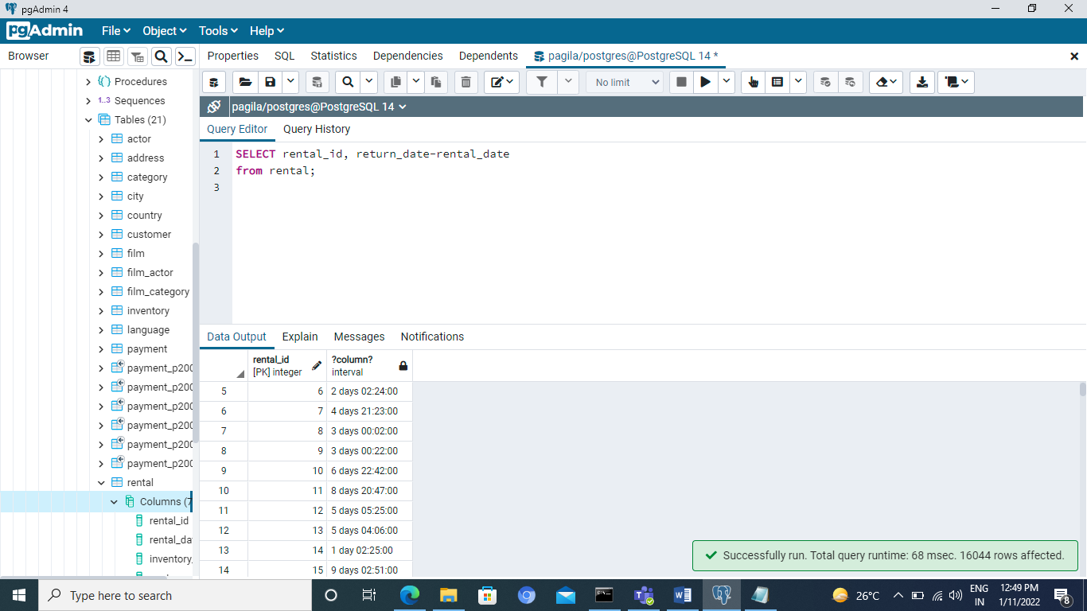

Section=4

